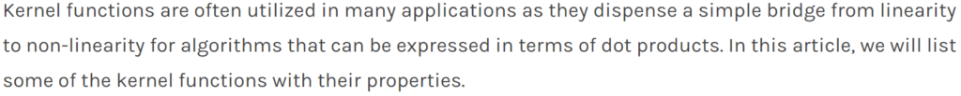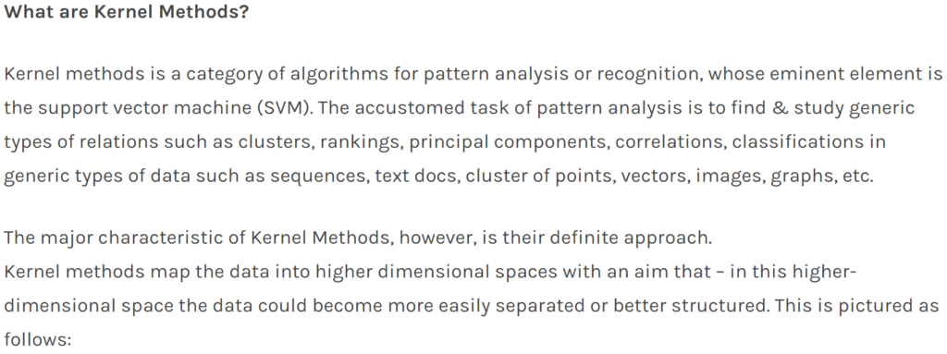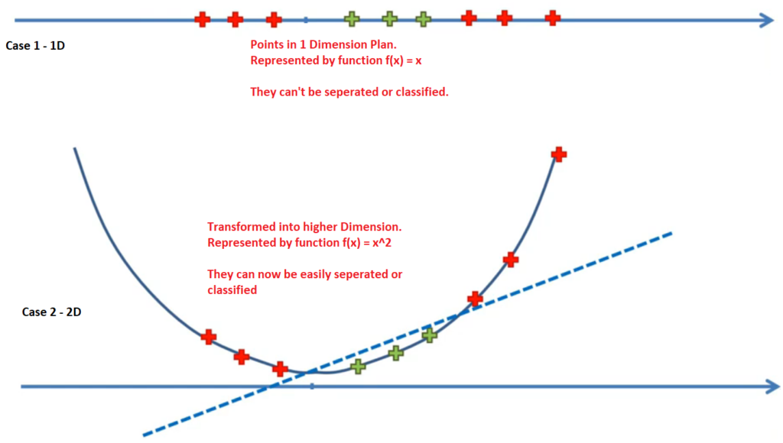

**What is the Kernel Trick?**

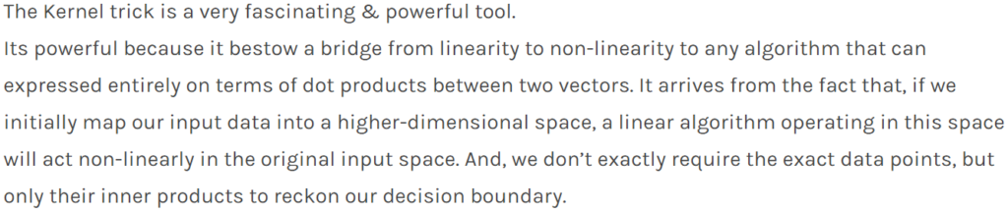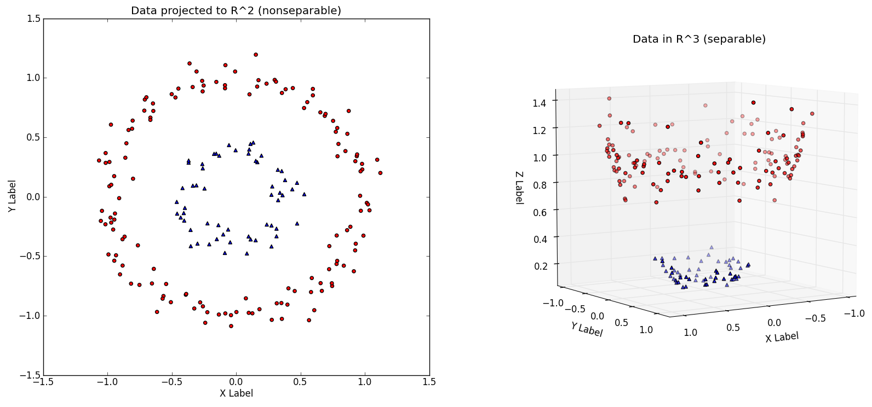

**Kernel Functions**

Below is a list of some kernel functions:

***Polynomial Kernel***

The Polynomial kernel is a non-stationary kernel.

k(x, y) = (alpha x^T y + c)^d 

Adjustable parameters are :

* constant term **c**
* slope **alpha**
* polynomial degree **d**.

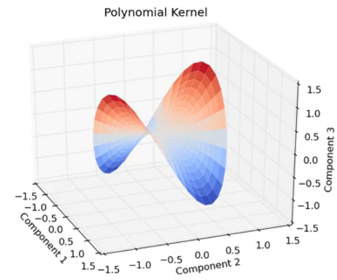

***Gaussian Kernel***

k(x, y) = expleft(-frac{ lVert x-y rVert ^2}{2sigma^2}right) 

Alternatively, it could also be implemented using

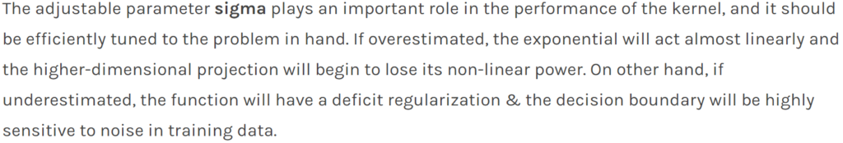

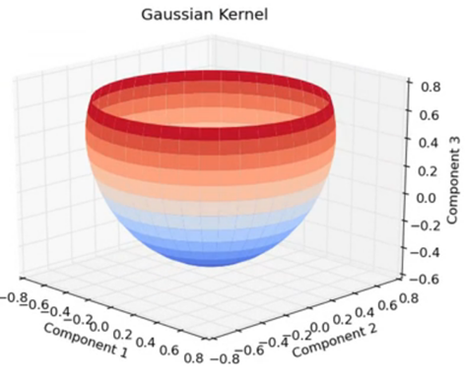

***Laplacian Kernel***

k(x, y) = expleft(- frac{lVert x-y rVert }{sigma}right)

It’s important to list that the observations made about the sigma parameter for the Gaussian kernel also apply to the Exponential and Laplacian kernels.

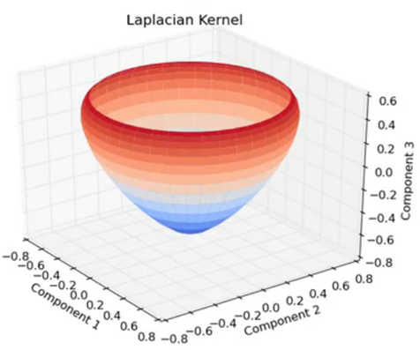

***Sigmoid Kernel***



k(x, y) = tanh (alpha x^T y + c) 

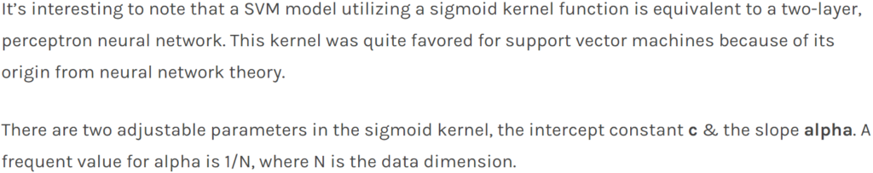

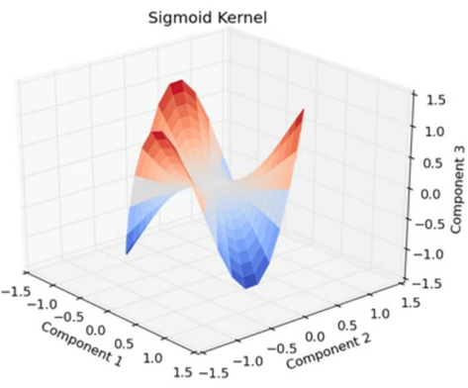

***Chi-Squared Kernel***

The Chi-Square kernel originates from the Chi-Square distribution:

k(x,y) = 1 - sum_{i=1}^n frac{(x_i-y_i)^2}{frac{1}{2}(x_i+y_i)}

However, this version of the kernel is only conditionally positive-definite (CPD). A positive-definite version of this kernel is given as:



and is advisable to be used by methods other than support vector machines.

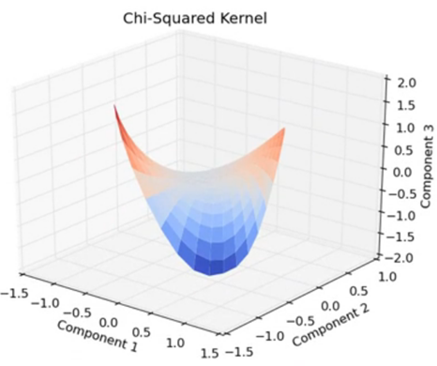

***Periodic Kernel***